Action Research Project Procedures

Step 1 Download Data:
- North Carolina Public Library Statistics | Library of NC
- Choose 3 separate annual periods. 2021-2022, 2022-2023 & 2023-2024 were chosen for this project.
- Download the Excel Data Table for each of the 3 periods.
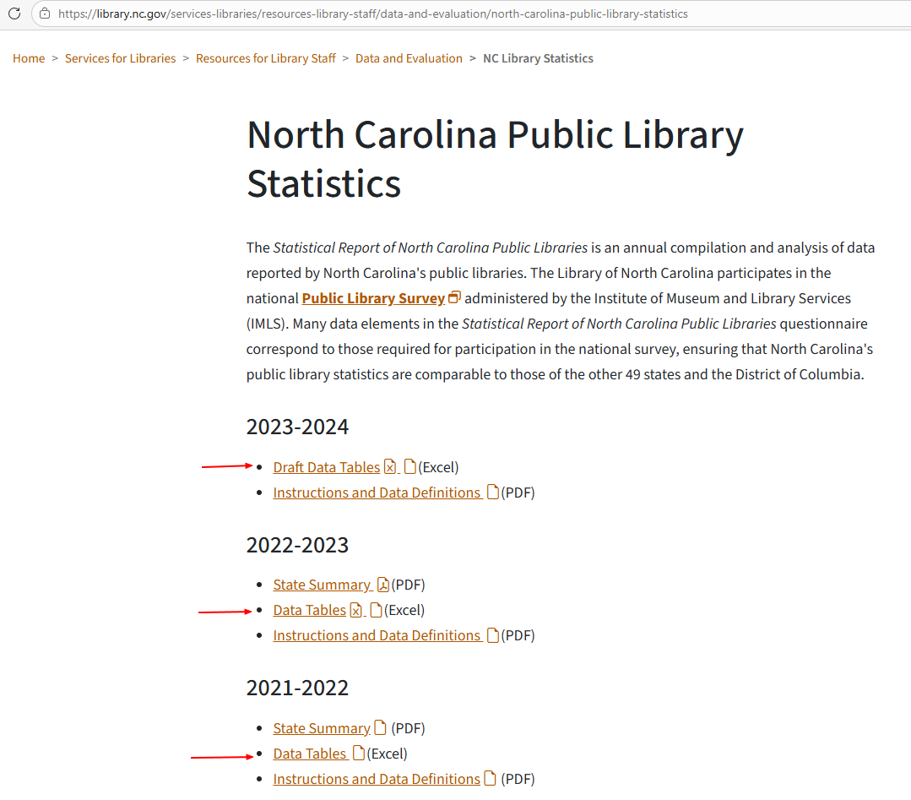
- The File will download as an Excel which can be saved at a location of your choosing.

- The Excel Spreadsheet is comprised of multiple tabs including:
  - Summary
  - Library Profiles
  - Staff
  - Salaries
  - Income
  - Income%
  - Expenditures
  - Collections
  - Collection %
  - Circulation
  - Circulation %
  - Service Measures
  - Programming
  - Technology
  - Summer Reading
  - Partnerships

Step 2 Use Copilot to Summarize the spreadsheet data:

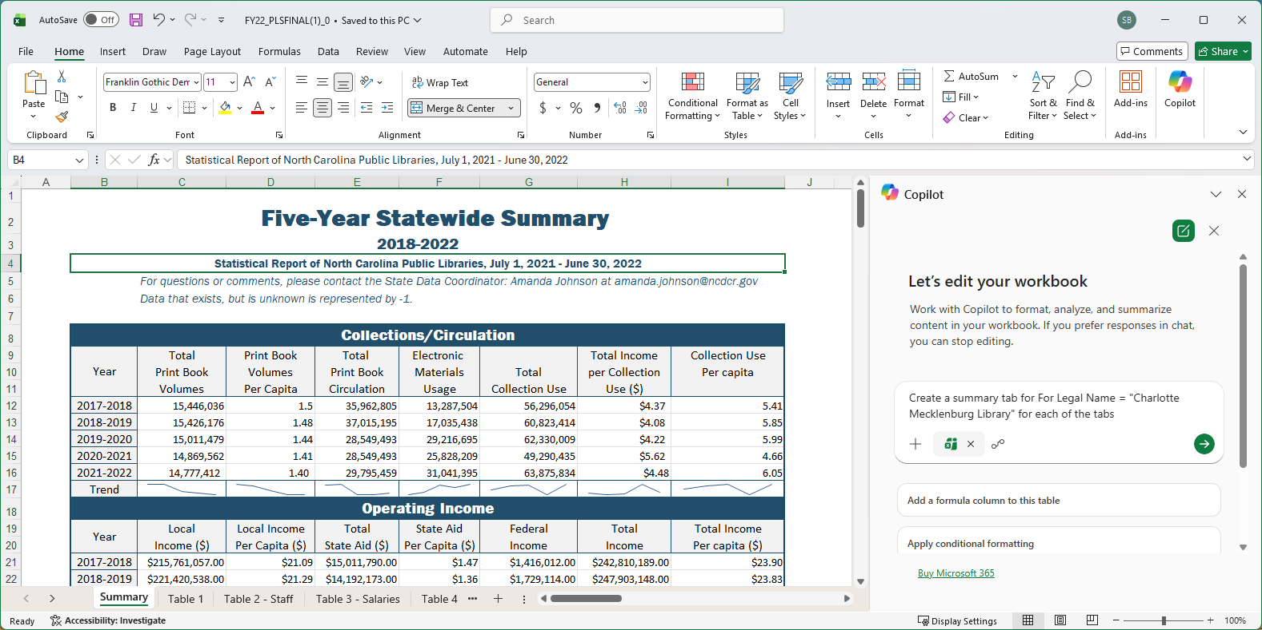

- Open one of the Microsoft Excel data files:

Open Copilot
Input the following prompt: Create a summary tab for For Legal Name = "Charlotte Mecklenburg Library" for each of the tabs
Click on the Green ‘Send’ button to submit the command.
- Copilot will create a summary report from all the tabs on one new tab.
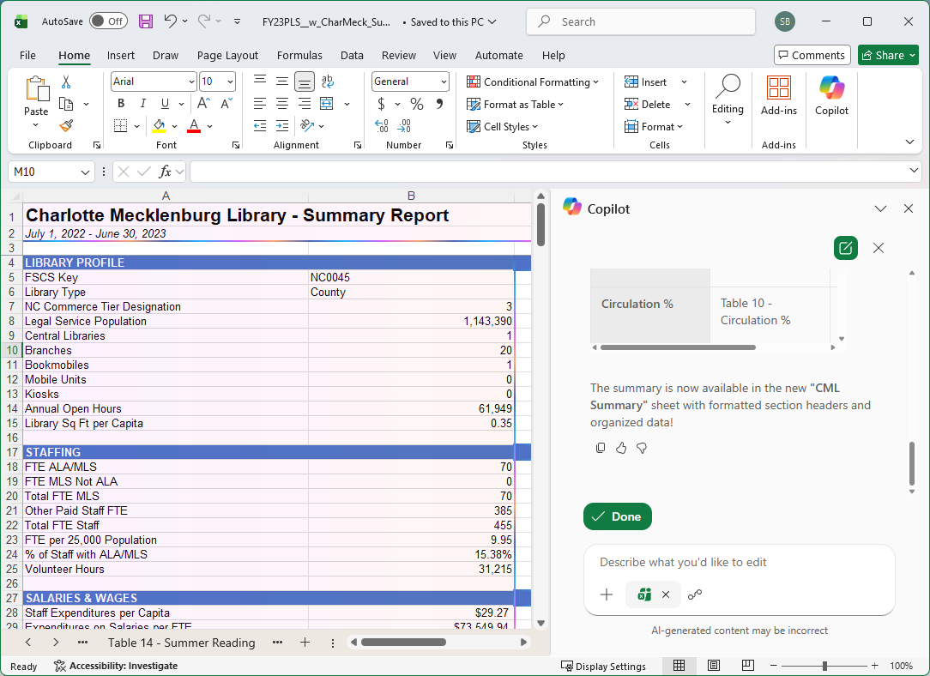

- Save the updated Excel Spreadsheet with the new tab.
- Repeat for each annual data file that you wish to compare.
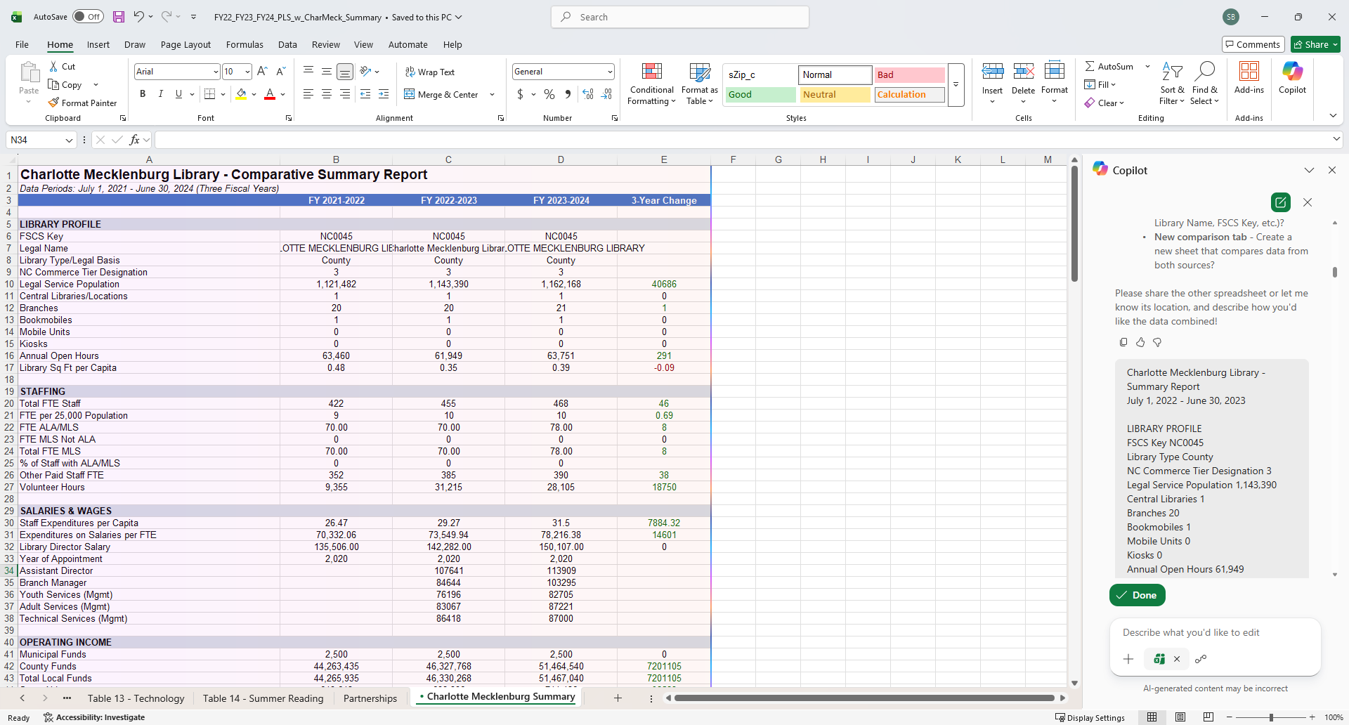

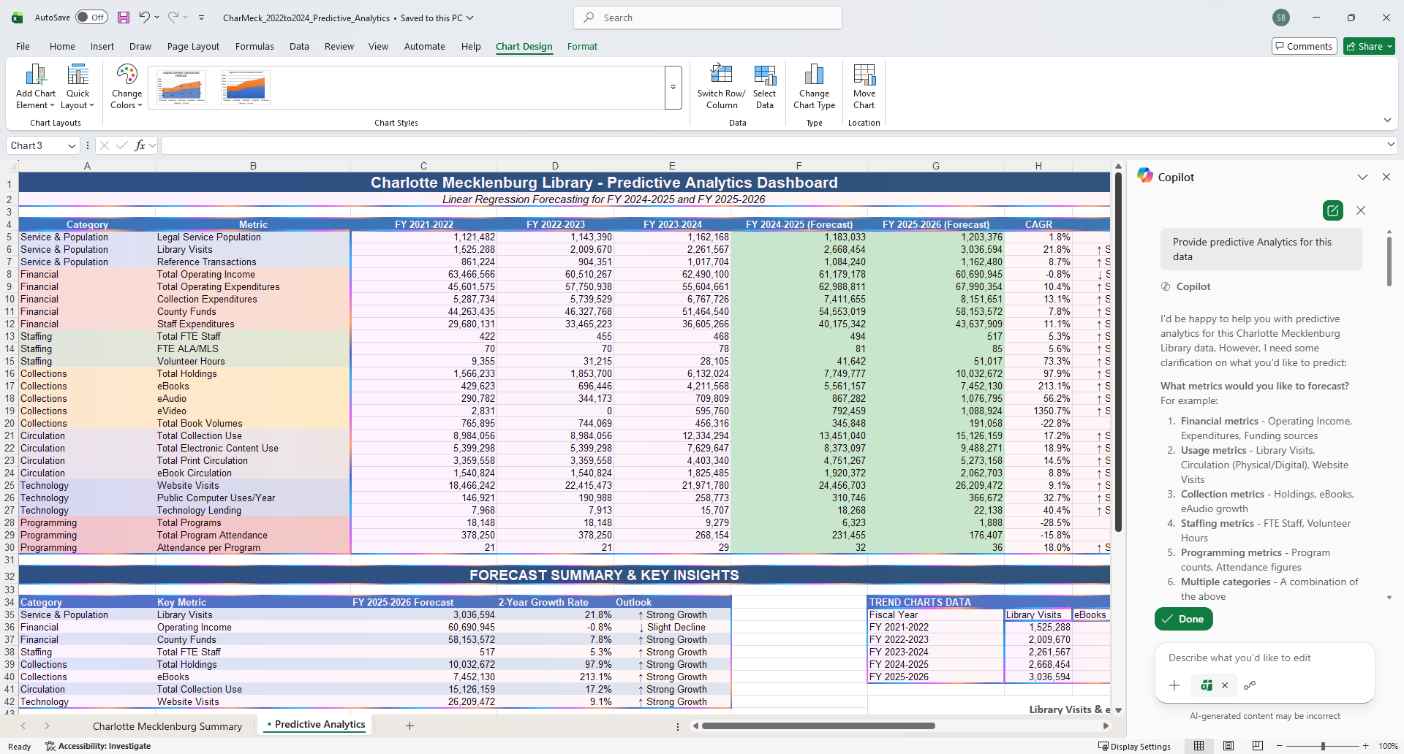
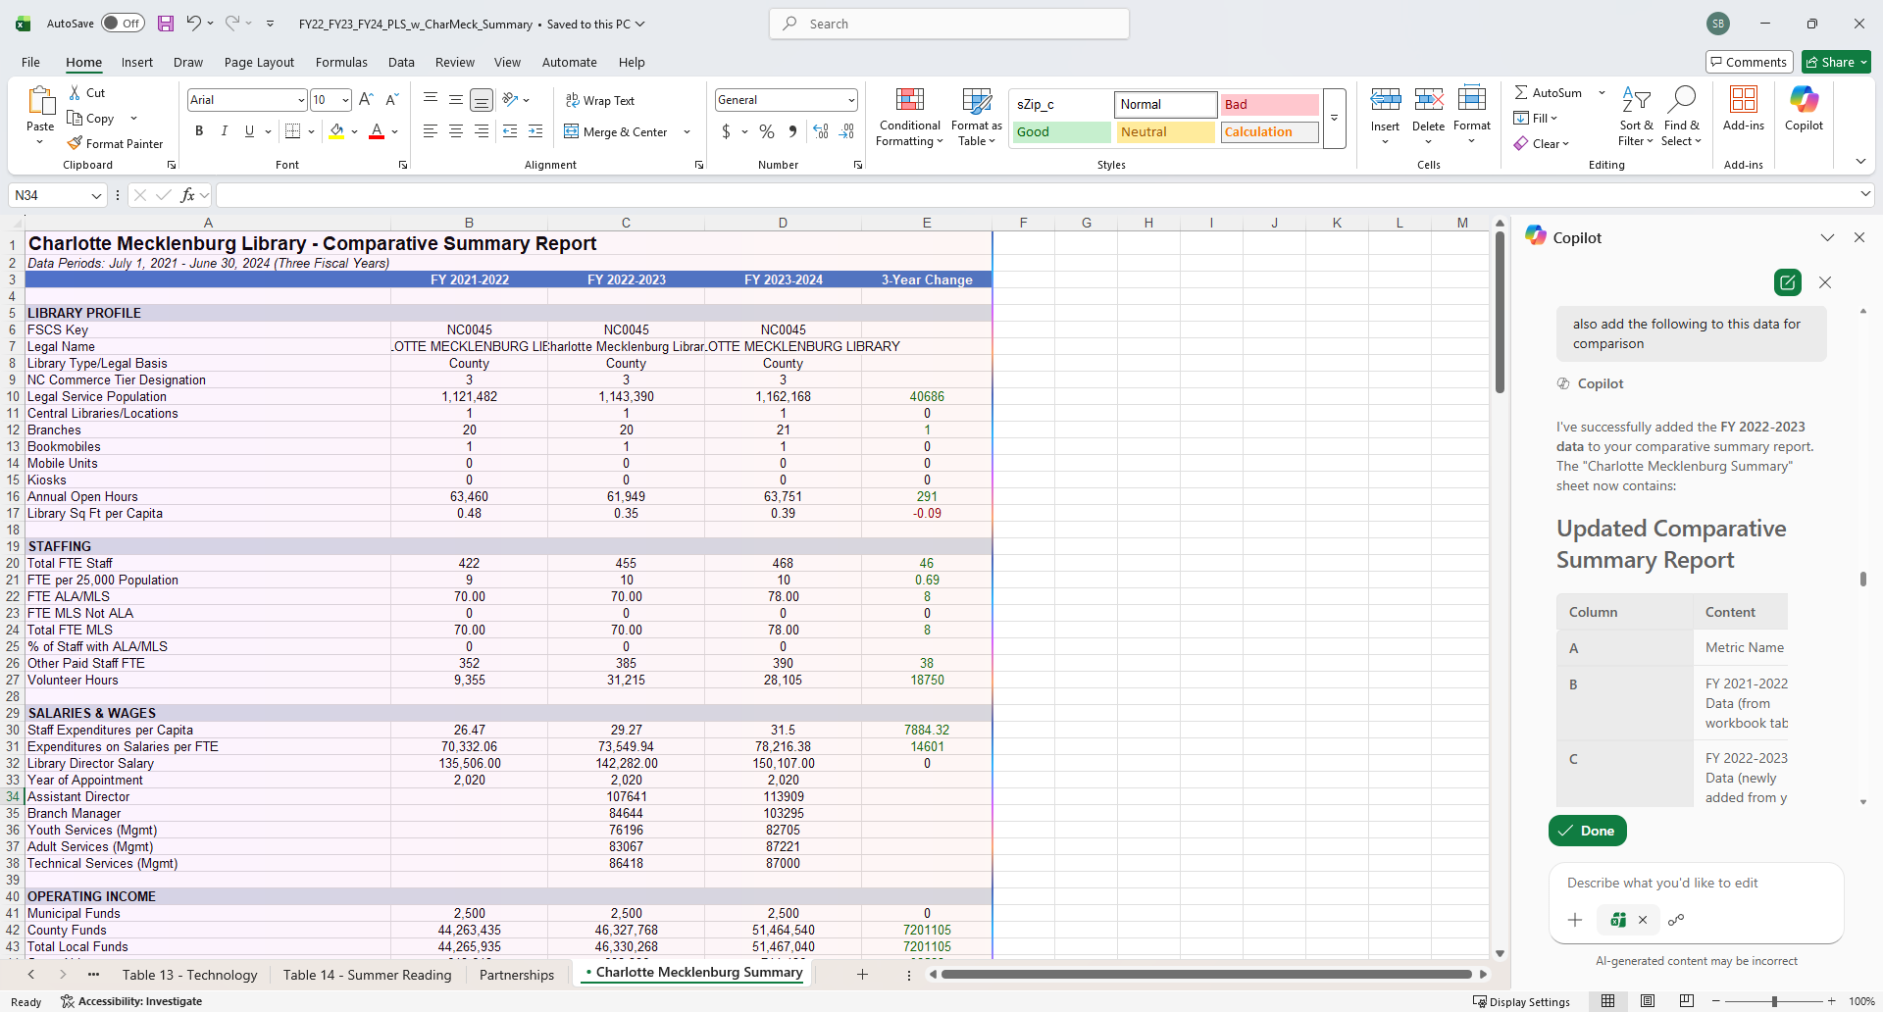

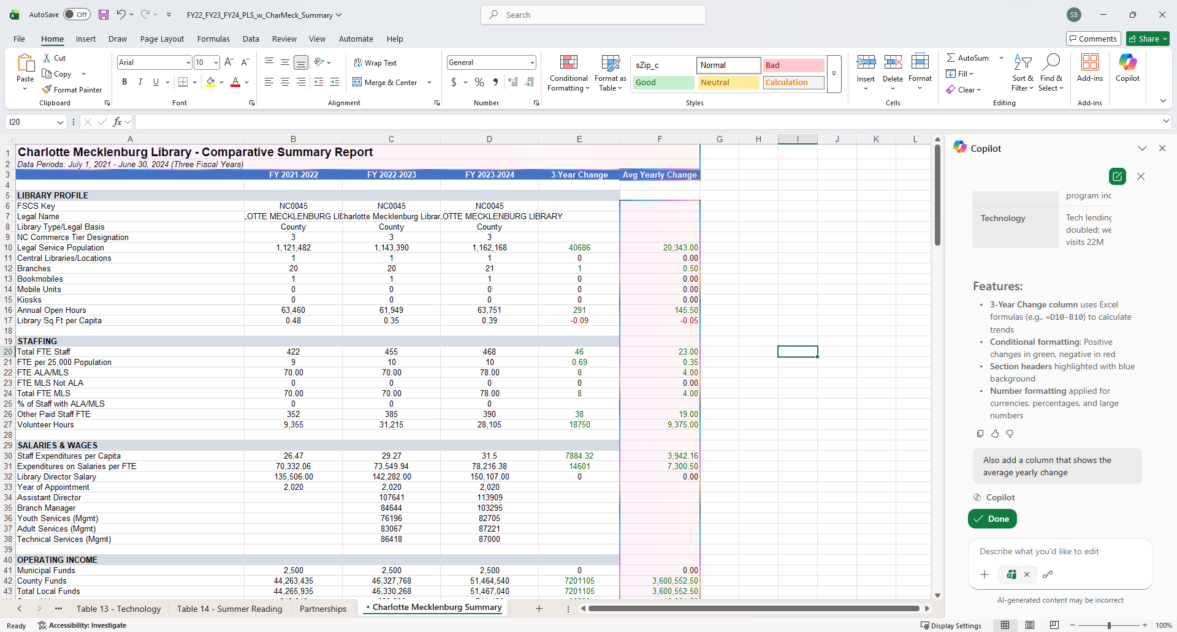

Predictive Analytics Methodology & Reasoning
Based on the Python code and the Predictive Analytics dashboard I created, here's the reasoning behind the predictive analytics approach:

1. Forecasting Method: Linear Regression
Why Linear Regression?
- Simplicity & Interpretability: Linear regression is a foundational statistical method that's easy to understand and explain to stakeholders
- Works with Limited Data: With only 3 years of historical data (FY 2021-2024), linear regression is appropriate—more complex models (like ARIMA or exponential smoothing) typically require more data points
- Trend Identification: It effectively captures the overall direction (upward/downward) of each metric
How It Works:
Forecast Value = Intercept + (Slope × Time Period)
- Uses scipy.stats.linregress() in Python (equivalent to Excel's FORECAST.LINEAR)
- Time periods: 1, 2, 3 (historical) → 4, 5 (forecast)

2. Growth Rate: Compound Annual Growth Rate (CAGR)
Why CAGR?
- Smooths Volatility: Unlike simple average growth, CAGR accounts for compounding effects
- Standard Business Metric: Widely used in finance and strategic planning for comparing growth rates across different metrics
Formula:
CAGR = (End Value / Start Value)^(1/n) - 1
Where n = 2 (the number of periods between FY 2021-2022 and FY 2023-2024)

3. Trend Classification Logic
Why Categorize Trends?
- Provides quick visual interpretation for decision-makers
- Highlights areas requiring attention (declining metrics) vs. successes (strong growth)
CAGR Range | Classification | Reasoning
> 5% | ↑ Strong Growth | Significantly outpacing typical inflation/population growth
0% to 5% | ↑ Growth | Positive but modest growth
-5% to 0% | ↓ Slight Decline | Minor decline, may be temporary
< -5% | ↓ Decline | Significant decline requiring attention

4. Metric Selection Rationale
26 metrics across 7 categories were selected to provide a holistic view:
Category | Reasoning
Service & Population | Measures community reach and demand
Financial | Tracks funding stability and spending efficiency
Staffing | Monitors human resource capacity
Collections | Tracks inventory and digital transformation
Circulation | Measures actual usage and engagement
Technology | Captures digital service adoption
Programming | Evaluates community programming effectiveness

5. Assumptions & Limitations
The methodology assumes:
- Trend Continuation: Historical patterns will continue into the future
- No External Shocks: No major events (pandemics, budget cuts, new branches) that would disrupt trends
- Linear Relationships: Growth/decline is constant over time (not exponential or logarithmic)
- Data Quality: The 3-year historical data is accurate and representative
Limitations Acknowledged:
- Only 3 data points limits statistical confidence (R² values may be low)
- Some metrics show irregular patterns (e.g., eVideo went from 2,831 → 0 → 595,760) which linear regression may not capture accurately
- External factors (economic conditions, policy changes) are not modeled

6. Why This Approach Was Chosen Over Alternatives
Alternative Method | Why Not Used
Moving Averages | Better for smoothing, not forecasting beyond current period
Exponential Smoothing | Requires more data points for reliable results
ARIMA/Time Series | Needs 20+ observations minimum
Machine Learning | Overkill for 3 data points; would overfit
Linear regression was the optimal choice given the data constraints while still providing actionable forecasts for strategic planning.

